Risk Identification Checklist
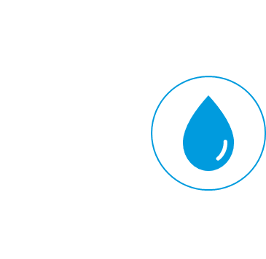  Water delivery by vendors | - Are all households able to get water?  - Will households be able to pay for water as incomes fall?  - Will vendors still be able to deliver water?  - Risks to continued supply at current levels:  - Can vendors’ bulk water source become unavailable?  - Can vendors get key input e.g. fuel?  - Can vendors be shut down by government fiat?  - Can those who cannot leave home get enough water brought to premises?  - Do households understand and apply hand-washing regime?
Stand-point supply | - What are social distancing arrangements at the stand-points?  - Is PPE available for staff / vendors?  - Will customers still be able to pay as incomes fall?  - Is water available, continuous, and expected to continue?  - Gap/risks for continued water supply at current levels:  - Lack of water in system  - Lack of electricity for pumping/lights  - Lack of staff  - Can those who cannot leave home get enough water brought to premises?  - Do households understand and apply hand-washing regime?
Piped to premises-intermittent | - Is water supply + on-site storage adequate for hygiene needs in households, especially when people must stay home (lock-down or self-isolation of vulnerable)?  - Will customers still be able to pay as incomes fall?  - Are there risks to water supply  - Power cuts?  - Chemical shortages?  - Equipment shortages?
Continuous  on-premises supply | - Will customers still be able to pay as incomes fall?  - Are there risks to water supply?  - Power cuts?  - Chemical shortages?  - Are there equipment shortages?
Utility as a whole | - Does the utility have funds to keep paying operating expense (OPEX)?  - Are there PPE and physical distancing arrangements for staff?  - Are utilities still able to read meters, bill, collect money?  - Are there arrangements for physical distancing of customers in commercial offices?  - Are there risks to water supply:  - Power cuts?  - Chemical shortages?  - Equipment shortages?  - Is the utility able to increase water available:  - By NRW reduction?  - By demand-side management?  - By boreholes or other quick schemes?  - Does the utility have funds for capital expense (CAPEX)?  - Is the utility able to procure and contract works rapidly?

